**MAHARAJA AGRASEN INSTITUTE OF TECHNOLOGY**

**VISION**

To nurture young minds in a learning environment of high academic value and imbibe spiritual and ethical values with technological and management competence.

**MISSION**

The Institute shall endeavor to incorporate the following basic missions in the teaching methodology:

**Engineering Hardware – Software Symbiosis**

Practical exercises in all Engineering and Management disciplines shall be carried out by Hardware equipment as well as the related software enabling deeper understanding of basic concepts and encouraging inquisitive nature.

**Life – Long Learning**

The Institute strives to match technological advancements and encourage students to keep updating their knowledge for enhancing their skills and inculcating their habit of continuous learning.

**Liberalization and Globalization**

The Institute endeavors to enhance technical and management skills of students so that they are intellectually capable and competent professionals with Industrial Aptitude to face the challenges of globalization.

**Diversification**

The Engineering, Technology and Management disciplines have diverse fields of studies with different attributes. The aim is to create a synergy of the above attributes by encouraging analytical thinking.

**Digitization of Learning Processes**

The Institute provides seamless opportunities for innovative learning in all Engineering and Management disciplines through digitization of learning processes using analysis, synthesis, simulation, graphics, tutorials and related tools to create a platform for multi-disciplinary approach.

**Entrepreneurship**

The Institute strives to develop potential Engineers and Managers by enhancing their skills and research capabilities so that they become successful entrepreneurs and responsible citizens.

**MAHARAJA AGRASEN INSTITUTE OF TECHNOLOGY**

**COMPUTER SCIENCE & ENGINEERING DEPARTMENT**

**VISION**

“To be centre of excellence in education, research and technology transfer in the field of computer engineering and promote entrepreneurship and ethical values.”

**MISSION**

“To foster an open, multidisciplinary and highly collaborative research environment to produce world-class engineers capable of providing innovative solutions to real life problems and fulfil societal needs.”

**EXPERIMENT - 1**

**Aim:** Introduction to computer networks

**Question:** What is a computer network?

**Answer:** A computer network is a collection of interconnected computers and devices that

are capable of sharing data and resources. These networks can be wired (using cables and physical connections) or wireless (using radio waves or other wireless technologies). The primary purpose of computer networks is to facilitate communication and data exchange between devices, allowing them to share information, access the internet, share files and resources (such as printers or storage), and collaborate effectively.

Here's a simple table outlining the key components and types of computer networks:

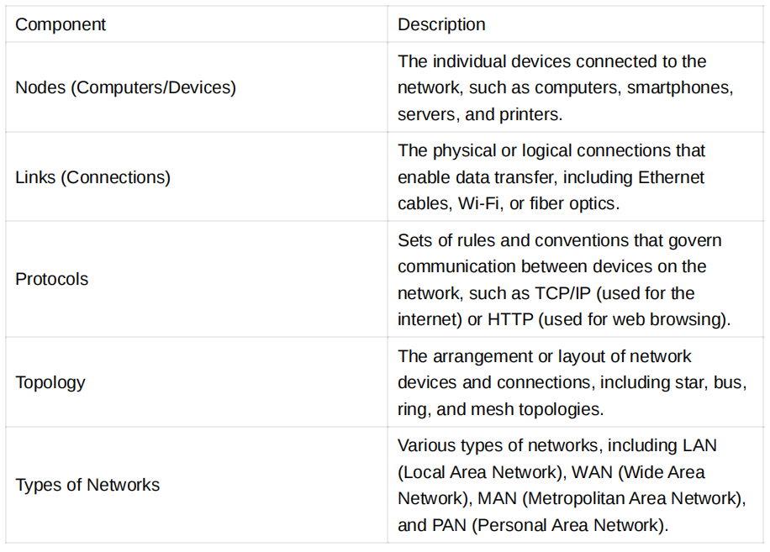

**Question:** What is a system?

**Answer:** A system is a collection of interrelated components or elements that work together

to achieve a common goal or purpose. Systems can vary in complexity and can be found in various domains, including engineering, biology, sociology, and computer science. In the context of computer science and software engineering, a system typically refers to a combination of hardware, software, data, and processes designed to perform specific functions or tasks.

Here's a table summarizing the key components of a system:

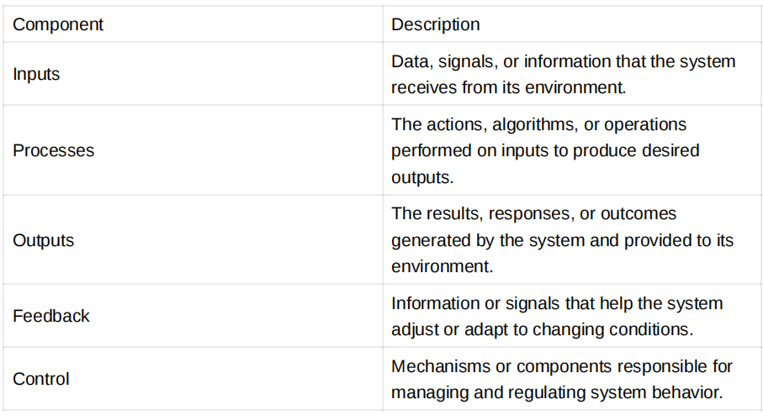

**Question: What is a simulator?**

**Answer:** A simulator is a software or hardware tool designed to mimic the behavior of a real

world system, process, or environment. Simulators are used for various purposes,

including training, testing, experimentation, and analysis. They allow users to interact

with a simulated version of a system without the risks or costs associated with the

real thing. Simulators are commonly used in fields such as aviation, automotive

engineering, and computer science.

**Question:** What is an emulator?

**Answer:** An emulator is similar to a simulator but typically focuses on replicating the

hardware and software environment of a specific system or device, such as a gaming console, mobile phone, or computer. Emulators are often used for running software or applications designed for one platform on another, allowing compatibility between different systems. For example, an Android emulator can run Android apps on a Windows computer.

**Question:** What is a mathematical proof of correctness?

**Answer:** A mathematical proof of correctness is a rigorous and formal method used in

software engineering and computer science to demonstrate that a computer program or algorithm meets its specified requirements and produces the correct results for all possible inputs and conditions. It involves using mathematical techniques and logic to establish that the program behaves as intended and avoids errors, such as bugs or unexpected behaviors.

The proof of correctness typically includes the following key steps:

1. **Specification**: Clearly define the requirements and expected behavior of the program or algorithm.
2. **Formalization**: Represent the program's logic and operations using mathematical notation.
3. **Preconditions and Postconditions**: Define preconditions (conditions that must be true before execution) and postconditions (conditions that must be true after execution) for each part of the program.
4. **Invariants**: Identify and prove loop invariants (properties that remain true during loop execution).
5. **Proof Techniques**: Use various proof techniques, such as mathematical induction or proof by contradiction, to demonstrate correctness. Proofs of correctness are essential for critical systems, where errors could have severe consequences, such as in aerospace, healthcare, and finance.

**Question:** What is the difference between continuous and discrete systems?

**Answer:** Continuous and discrete systems are two fundamental types of systems in various

fields, including engineering and computer science. Here's a comparison:

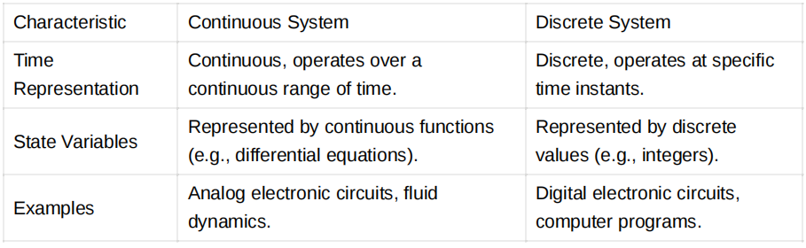

In a continuous system, time and state variables are continuous, meaning they can take any value within a range. In contrast, discrete systems operate at specific discrete time steps, and state variables are represented by discrete values.

**Question: What is discrete event simulation?**

**Answer:** Discrete event simulation is a modeling and simulation technique used to study the

behavior of complex systems that evolve over time based on discrete events. It involves modeling the system's components, events, and interactions and then simulating their behavior over discrete time intervals. This approach is particularly useful for systems where significant changes occur only at specific points in time, such as queuing systems, manufacturing processes, and computer networks.

Key components of discrete event simulation include:

* **Entities**: Represent objects or elements within the system that can move through various states or processes.
* **Events**: Occurrences that trigger changes in the system's state or the entities' behavior.
* **Queues**: Used to manage entities awaiting processing or service.
* **Simulation clock**: Keeps track of the current simulation time. Discrete event simulation is employed in various domains for performance analysis, optimization, and decision-making.

**Question:** What are the various types of simulators available?

**Answer:** Simulators come in various types, depending on their applications and purposes.

Here are some common types of simulators:

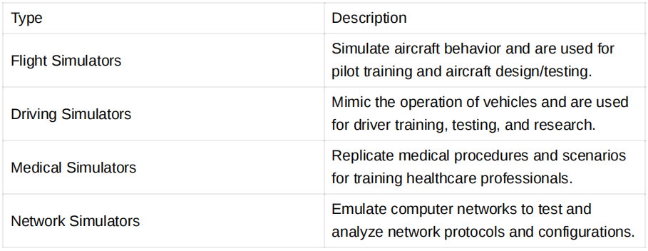

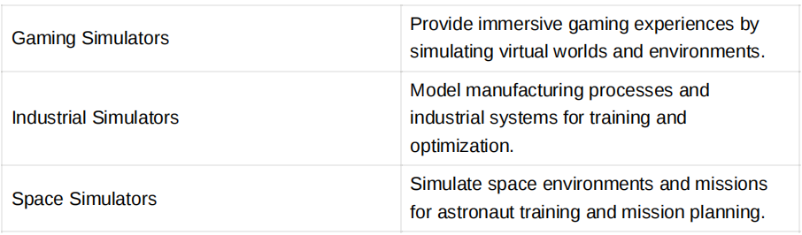

The choice of simulator type depends on the specific application and goals.

**Question:** Explain at least seven networking simulators.

**Answer:** Here are seven popular networking simulators, along with a brief description of each:

1. **NS-2 (Network Simulator 2)**: NS-2 is an open-source discrete event simulator primarily used for network protocol research and development. It supports various network types, including wired and wireless networks. Written in C++ and Tcl, it allows users to design and evaluate network protocols and scenarios.

2. **NS-3 (Network Simulator 3)**: NS-3 is the successor to NS-2 and provides a more modern and extensible platform for network simulation. It is also open-source and supports various network technologies, including Wi-Fi, LTE, and IPv6. NS-3 is written in C++ and offers a Python binding for scripting.

3. **Cisco Packet Tracer**: Packet Tracer is a network simulation tool developed by Cisco Systems. It is widely used for teaching and learning networking concepts, especially in Cisco's networking courses. Packet Tracer allows users to create and simulate network topologies.

4. **GNS3 (Graphical Network Simulator-3)**: GNS3 is an open-source network emulator used for designing and testing complex network topologies.It integrates with real network devices, such as routers and switches, making it valuable for network engineers.

5. **EVE-NG (Emulated Virtual Environment - Next Generation)**: EVE-NG is a network emulation platform that allows users to emulate a wide range of network devices, including Cisco, Juniper, and more. It is commonly used for network certification exam preparation and lab testing.

6. **OpNet (now part of Riverbed SteelCentral)**: OpNet is a commercial network modeling and simulation tool used for performance analysis and capacity planning. It offers features for simulating various network technologies and predicting network behavior.

7. **OMNeT++**: OMNeT++ is a discrete event simulation framework used for modeling and

simulating communication systems and protocols. It is extensible and suitable for research in wireless and mobile networks. These simulators cater to different needs, from research and education to network design and testing.

**Question:** What is the difference between NS-2 and NS-3?

**Answer:**

NS-2 and NS-3 are both network simulators, but they have notable differences:

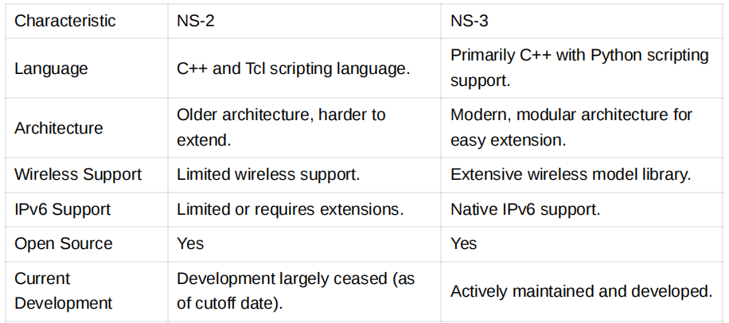

NS-3 is generally considered a more advanced and versatile network simulator,

especially for wireless and modern network protocols. Researchers and developers

often prefer NS-3 due to its active development community and better support for

contemporary networking technologies.

**Question:** Explain in detail with all the available functionality about Packet Tracer and Wireshark.

**Answer:**

**Packet Tracer:**

Description: Cisco Packet Tracer is a network simulation and visualization tool developed by Cisco Systems. It is primarily used for teaching and learning networking concepts, especially in Cisco's networking courses.

**Key Features**:

* Network Topology Simulation: Users can create, configure, and simulate network topologies, including routers, switches, PCs, and other networking devices.
* Packet Simulation: Packet Tracer allows users to generate and track network packets, making it a valuable tool for understanding how data flows within a network.
* Device Configuration: Users can configure devices using a command-line interface (CLI) similar to Cisco's real networking devices.
* Packet Capture: Packet Tracer provides basic packet capture and analysis capabilities, allowing users to inspect network traffic.
* Protocols Supported: It supports a range of network protocols, including TCP/IP, DHCP, HTTP, and more.
* Collaboration: Packet Tracer offers collaboration features, enabling multiple users to work on the same network project simultaneously.
* IoT Simulation: It includes support for simulating Internet of Things (IoT) devices and scenarios.

**Use Cases**:

* Education: Packet Tracer is widely used by educators and students to teach and learn networking concepts, Cisco commands, and network design.
* Network Prototyping: It can be used for quickly prototyping network configurations and testing Cisco device configurations in a safe virtual environment.
* Certification Preparation: Individuals preparing for Cisco certification exams often use Packet Tracer to practice hands-on networking tasks.

**Wireshark:**

Description: Wireshark, formerly known as Ethereal, is a powerful open-source packet analysis tool used for network troubleshooting, analysis, and protocol development.

**Key Features**:

* Packet Capture: Wireshark can capture and display packets from a network interface in real-time.
* Protocol Analysis: It provides detailed protocol analysis, allowing users to dissect and analyze network traffic at a granular level.
* Filtering and Searching: Users can apply filters and search for specific packets or packet attributes, making it easy to isolate and examine relevant data.
* Packet Decoding: Wireshark can decode various network protocols, making it an invaluable tool for diagnosing network issues.
* Statistics: It offers statistics and summary information about captured packets, such as protocol distribution and bandwidth usage.
* Export and Save: Users can save captured packets in various file formats or export them for further analysis.
* Scripting and Automation: Wireshark supports scripting and automation through tools like TShark and Lua.
* Cross-Platform: Available on multiple operating systems, including Windows, macOS, and Linux.

**Use Cases**:

* Network Troubleshooting: Wireshark is used by network administrators and engineers to diagnose network problems and identify the root causes of issues.
* Security Analysis: It can be used to detect and investigate network security incidents, such as malware infections and suspicious network traffic.
* Protocol Development: Wireshark is essential for developers working on new network protocols or troubleshooting existing ones.
* Educational and Training: It is used in networking courses and security training programs to teach students about network analysis and forensics.

# **EXPERIMENT – 2**

**Aim:** Installation of Cisco Packet Tracer.

**Theory:** Cisco Packet Tracer is a network simulation and visualization tool developed by Cisco Systems. It is primarily used for teaching and learning networking concepts, allowing users to create virtual network environments and simulate network behavior. Packet Tracer provides a graphical interface that enables users to design, configure, and troubleshoot networks without needing physical hardware.

**Key features of the Cisco Packet Tracer include:**

**1. Network topology creation:** Users can create network topologies by dragging and dropping devices such as routers, switches, PCs, servers, and more onto a virtual workspace.

**2. Device configuration:** Users can configure the devices in the network, including setting IP addresses, enabling routing protocols, configuring security features, and implementing advanced network configurations.

**3. Network simulation:** Packet Tracer simulates network behaviors and allows users to observe the flow of data packets, inspect network traffic, and analyze network performance.

**4. Protocols and technologies:** Packet Tracer supports a wide range of networking protocols and technologies, including Ethernet, TCP/IP, routing protocols (e.g., OSPF, EIGRP), switching protocols (e.g., VLANs, STP), wireless networking, and security features (e.g., firewalls, VPNs).

**5. Collaboration and learning:** Packet Tracer offers collaborative features that enable users to work together on network projects and share their work. It is widely

used in educational institutions to teach networking concepts and facilitate hands-on learning experiences.

**6. Assessment and evaluation:** Packet Tracer includes built-in assessment tools that allow instructors to create and distribute activities, quizzes, and exams to evaluate students' understanding of networking concepts and ability to configure and troubleshoot networks.

**7. Multi-platform support:** Cisco Packet Tracer is available for Windows, macOS, and Linux operating systems, making it accessible to many users.

Packet Tracer is widely used by networking students, instructors, and professionals to gain practical experience in designing, configuring, and troubleshooting network environments. It helps users develop their networking skills in a virtual, risk-free environment before working with physical network equipment.

**Installing Packet Tracer on Linux:**

1. Download Packet Tracer: Visit the Cisco Networking Academy website (https://www.netacad.com/) and log in with your account. Navigate to the Packet Tracer download page and download the Linux version of Packet Tracer. Ensure you select the appropriate version for your Linux distribution.
2. Open the terminal: Launch the terminal application on your Linux system. You can usually find it in the applications menu or by pressing Ctrl+Alt+T.
3. Navigate to the directory: Use the `cd` command to navigate to the directory where the downloaded Packet Tracer file is located. For example, if it's in the Downloads folder, you can use the following command:
   1. cd ~/Downloads
4. Extract the archive: Extract the downloaded Packet Tracer archive using the`tar` command. Replace`PacketTracer.tar.gz` with the actual name of the downloaded file.
   1. tar -xvzf PacketTracer.tar.gz
5. Navigate to the extracted directory: Use the `cd` command to navigate to the extracted Packet Tracer directory.
   1. cd PacketTracer
6. Run the installation script: Execute the installation script with administrative privileges using the `sudo` command.
   1. sudo ./install
   2. Enter your password when prompted.
7. Follow the on-screen prompts: The installation script will guide you through the installation process. Read and accept the end-user license agreement, and follow the prompts to complete the installation.
8. Launch Packet Tracer: After the installation completes successfully, you can launch Packet Tracer from the applications menu or by running the following command:
   1. packettracer
9. This will start Cisco Packet Tracer on the Linux system.

# **EXPERIMENT – 3**

**Aim:** To implement the static routing using the Cisco packet tracer

**Theory:** Static routing in Cisco Packet Tracer is a fundamental networking concept where network administrators manually configure the routing table of a router, specifying the next hop or exit interface for each destination network.

This approach is suitable for smaller networks with relatively simple topologies, where routing decisions remain constant or change infrequently. Administrators define static routes by specifying the destination network and the associated next-hop router's IP address or directly connected interface.

Static routing offers simplicity and predictability, making it easier to troubleshoot and maintain, as it doesn't involve the complexities of dynamic routing protocols like OSPF or EIGRP. However, it is less adaptive to network changes, making it less suitable for large and dynamic networks. In Cisco Packet Tracer, network professionals can practice and experiment with static routing configurations, gaining a hands-on understanding of routing principles and helping them become proficient in managing network traffic efficiently within a controlled environment.

**Procedure:**

1. Open Cisco Packet Tracer and create a new project.
2. Drag and drop two "PC" devices from the "End Devices" section onto the workspace.
3. Configure IP addresses of the two devices (in this case 10.10.10.1 and 10.10.10.2 for PC0 and PC1 respectively).
4. Connect the two PC using a Copper Cross-Over wire.
5. In the command prompt of PC0 type in the following command to check the connection

ping 10.10.10.2

**Static Routing between two PC**

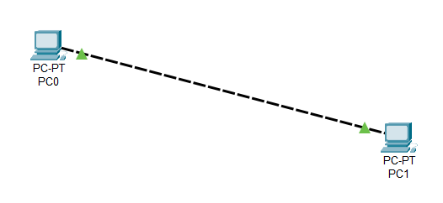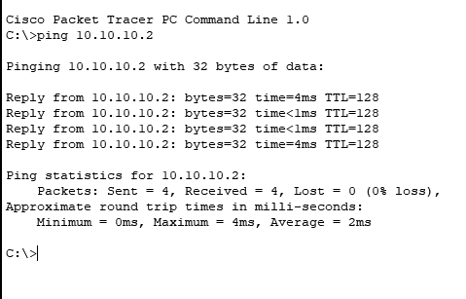

# **EXPERIMENT – 4**

**Aim:** To implement the DHCP using the Cisco packet tracer

**Theory:** Dynamic Host Configuration Protocol (DHCP) is a networking protocol used to automatically assign IP addresses and related configuration information to devices on a network. In Cisco Packet Tracer, DHCP plays a crucial role in simplifying the management of IP addresses and other network parameters. This protocol enables network administrators to automate the IP address allocation process, making it efficient and scalable for both small and large networks.

DHCP eliminates the need for manually configuring IP addresses on each device by centralizing the administration of IP leases. When a device, such as a computer or smartphone, connects to the network, it sends a DHCP request. A DHCP server, typically a router or dedicated server, responds with an available IP address and other network settings, including subnet mask, gateway, DNS servers, and lease duration.

Cisco Packet Tracer allows users to simulate the deployment of DHCP servers and clients, offering a practical platform for understanding and configuring DHCP settings within a controlled network environment. By using Packet Tracer, network administrators and students can experiment with different DHCP configurations, such as setting address pools, lease times, and reservation of specific IP addresses for devices, thereby gaining a deep understanding of how DHCP streamlines IP management, enhances network efficiency, and simplifies the provisioning and maintenance of IP configurations in real-world networking scenarios.

**Procedure:**

1. Open Cisco Packet Tracer and create a new project.
2. Drag and drop three “PCs” from and one Server from “End Devices”
3. Drag and drop the “2960” Switch from “Switches” and place it in between the server and the three PCs.
4. Now connect the server and the PCs to the switch using the “Copper Straight Through” wire.
5. Double-click on the Server and go to “Desktop”.
6. Now in the “IP Configuration”, click on static and put it in the IPv4 address as 192.168.1.1 and click on the subnet mask(255.255.255.0)
7. Now go to the “Services” section in the Server and click on DHCP.
8. Now turn on the service by pressing the toggle button
9. Put the “Default Gateway”, “DNS Server”, “Start Address” and “Subnet Mask” as 192.168.1.1, 192.168.1.1, 192.168.1.2, and 255.255.255.0 respectively
10. Click on save.
11. Now click on PC0, go to “IP Configuration” in the “Desktop” Section and click on DHCP.
12. You shall see the message “DHCP Request Successfully”
13. Do the same for the remaining two PCs.

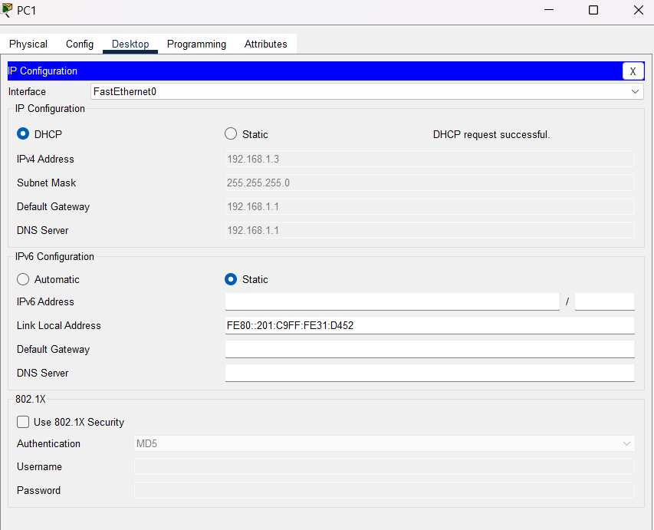**DHCP Configuration**

# 

# 

# **EXPERIMENT – 5**

**Aim:** Create Bus, Star, Mesh, and hybrid topology using Cisco Packet Tracer.

**Theory:** Cisco Packet Tracer is a network simulation and visualization tool developed by Cisco Systems. It is primarily used for teaching and learning networking concepts, allowing users to create virtual network environments and simulate network behaviors. Packet Tracer provides a graphical interface that enables users to design, configure, and troubleshoot networks without needing physical hardware.

**Procedure:**

To create different network topologies using Cisco Packet Tracer, follow these steps:

**Bus Topology:**

1. Open Cisco Packet Tracer and create a new project.
2. Drag and drop a "Switch" device from the "End Devices" section onto the workspace.
3. Connect multiple PCs to the Hub by dragging and dropping them onto the workspace and then connecting them to the Hub using Ethernet cables.
4. Arrange the PCs and Hub in a linear fashion to represent the bus topology.
5. Configure IP addresses and other necessary settings for each PC if required.

**Star Topology:**

1. Create a new project in Cisco Packet Tracer.
2. Drag and drop a "Switch" device from the "Switches" section onto the workspace.
3. Connect multiple PCs to the Switch by dragging and dropping them onto the workspace and then connecting them to the Switch using Ethernet cables.
4. Arrange the PCs around the Switch in a star-like pattern, with each PC connected directly to the Switch.
5. Configure IP addresses and other necessary settings for each PC if required.

**Mesh Topology:**

1. Begin a new project in Cisco Packet Tracer.
2. Drag and drop multiple "Switch" devices onto the workspace.
3. Connect the Switches to each other using Ethernet cables to create a fully connected mesh.
4. Drag and drop PCs onto the workspace and connect them to the Switches as required.
5. IF REQUIRED, Configure IP addresses and other necessary settings for each PC and Switch.

**Hybrid Topology:**

1. Open Cisco Packet Tracer and create a new project.
2. Combine elements from different topologies to create a hybrid topology that suits your requirements.

For example, you can connect multiple Switches in a mesh configuration, and then click a few PCs to one Switch to form a star topology.

1. Drag and drop the required devices onto the workspace and connect them using the appropriate cables.
2. Configure IP addresses and other necessary settings for each device as required.

**Bus Topology**

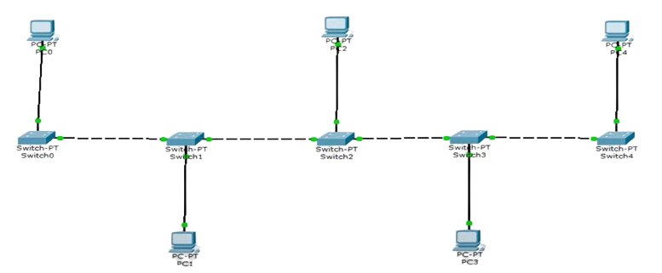

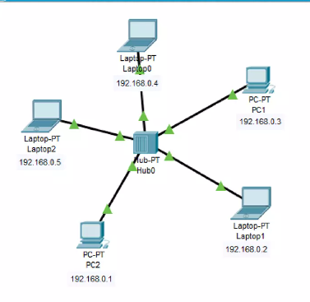**Star Topology**

**Mesh Topology**

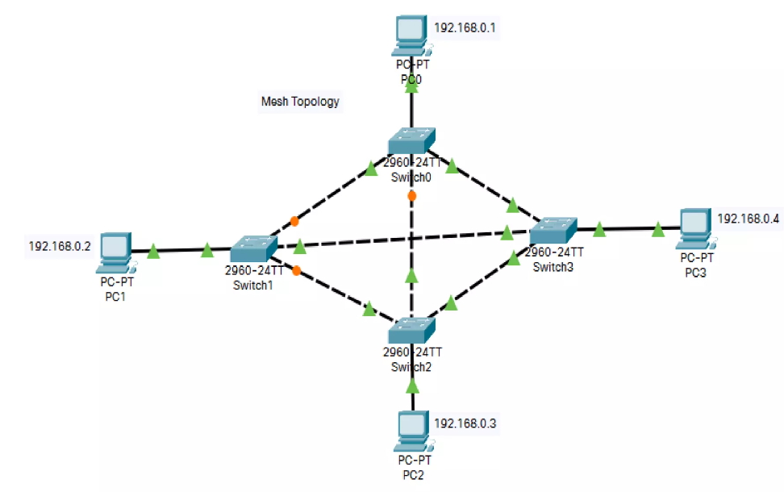

**Hybrid Topology**

